NHÓM10
Lê Đức Mạnh N22DCDT035
Cao Xuân Phi N22DCDT044
Lê Nguyễn Trọng Phước N22DCDT048
Lý Hữu Bằng N22DCDT007
Nguyễn Trần Văn An N22DCDT003
BÀI1 TEST + UART
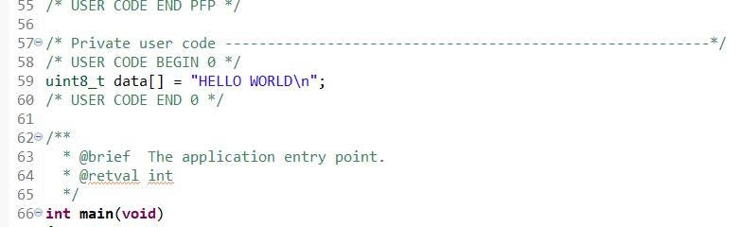
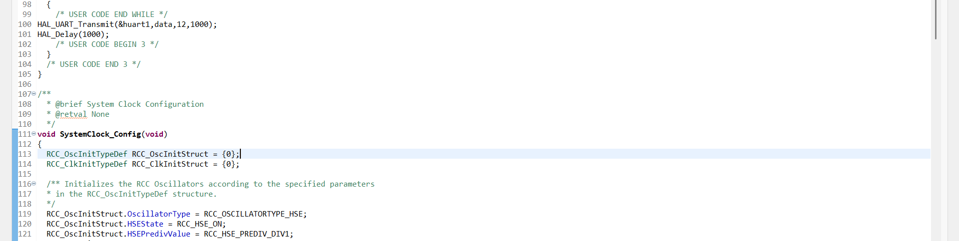
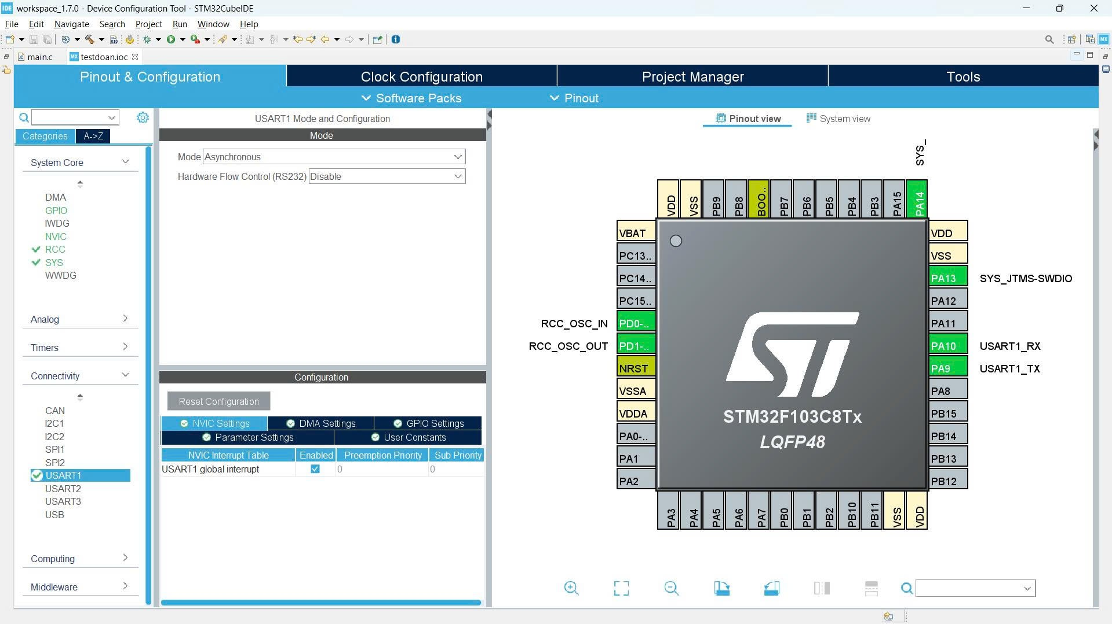
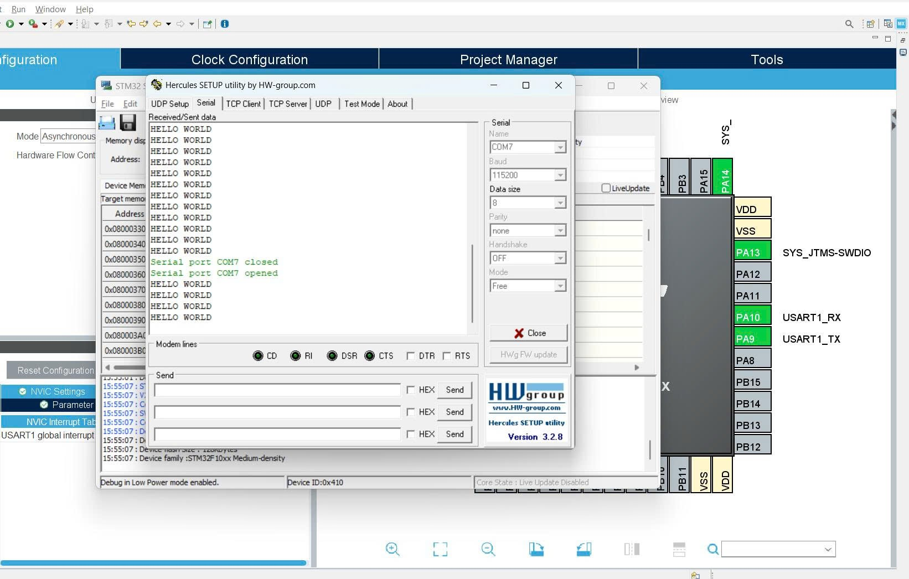

Bài2: biểu đồ serial monitor
Demo:
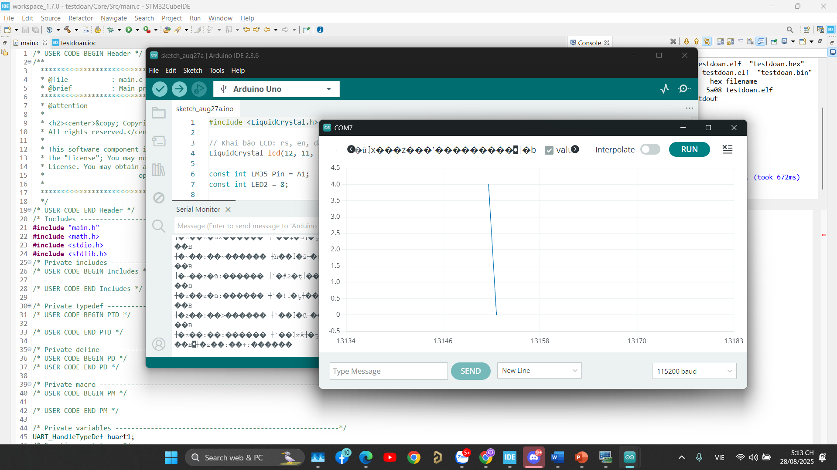
Sau khi fix:
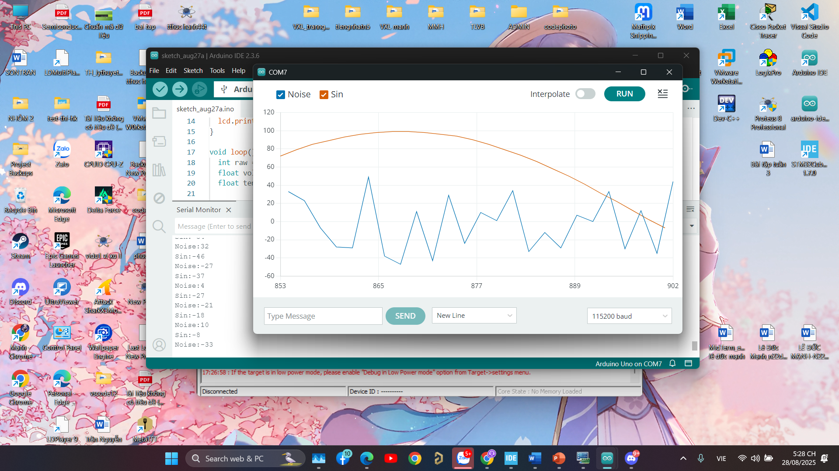
/* USER CODE BEGIN Header */
/**
******************************************************************************
* @file : main.c
* @brief : Main program body
******************************************************************************
* @attention
*
* <h2><center>&copy; Copyright (c) 2025 STMicroelectronics.
* All rights reserved.</center></h2>
*
* This software component is licensed by ST under BSD 3-Clause license,
* the "License"; You may not use this file except in compliance with the
* License. You may obtain a copy of the License at:
* opensource.org/licenses/BSD-3-Clause
*
******************************************************************************
*/
/* USER CODE END Header */
/* Includes ------------------------------------------------------------------*/
#include "main.h"
#include <math.h>
#include <stdio.h>
#include <string.h>
#include <stdlib.h>
/* Private includes ----------------------------------------------------------*/
/* USER CODE BEGIN Includes */

/* USER CODE END Includes */

/* Private typedef -----------------------------------------------------------*/
/* USER CODE BEGIN PTD */

/* USER CODE END PTD */

/* Private define ------------------------------------------------------------*/
/* USER CODE BEGIN PD */
/* USER CODE END PD */

/* Private macro -------------------------------------------------------------*/
/* USER CODE BEGIN PM */

/* USER CODE END PM */

/* Private variables ---------------------------------------------------------*/
UART_HandleTypeDef huart1;
char buf[64];
float wave = 0.0f;
/* USER CODE BEGIN PV */

/* USER CODE END PV */

/* Private function prototypes -----------------------------------------------*/
void SystemClock_Config(void);
static void MX_GPIO_Init(void);
static void MX_USART1_UART_Init(void);
/* USER CODE BEGIN PFP */

/* USER CODE END PFP */

/* Private user code ---------------------------------------------------------*/
/* USER CODE BEGIN 0 */

/* USER CODE END 0 */

/**
* @brief The application entry point.
* @retval int
*/
int main(void)
{
/* USER CODE BEGIN 1 */

/* USER CODE END 1 */

/* MCU Configuration--------------------------------------------------------*/

/* Reset of all peripherals, Initializes the Flash interface and the Systick. */
HAL_Init();

/* USER CODE BEGIN Init */

/* USER CODE END Init */

/* Configure the system clock */
SystemClock_Config();

/* USER CODE BEGIN SysInit */

/* USER CODE END SysInit */

/* Initialize all configured peripherals */
MX_GPIO_Init();
MX_USART1_UART_Init();
/* USER CODE BEGIN 2 */

/* USER CODE END 2 */

/* Infinite loop */
/* USER CODE BEGIN WHILE */
while (1)
{
/* USER CODE END WHILE */
// Tạo sóng sin biên độ 100
float sinwave = sinf(wave) * 100.0f;

// Nhiễu ngẫu nhiên từ -50 đến +50
int noise = (rand() % 101) - 50;

// Gửi giá trị sin
sprintf(buf, "Sin:%d\n", (int)sinwave);
HAL_UART_Transmit(&huart1, (uint8_t*)buf, strlen(buf), HAL_MAX_DELAY);

// Gửi giá trị noise
sprintf(buf, "Noise:%d\n", noise);
HAL_UART_Transmit(&huart1, (uint8_t*)buf, strlen(buf), HAL_MAX_DELAY);

wave += 0.1f; // tăng góc
HAL_Delay(50); // delay 50ms
/* USER CODE BEGIN 3 */
}
/* USER CODE END 3 */
}

/**
* @brief System Clock Configuration
* @retval None
*/
void SystemClock_Config(void)
{
RCC_OscInitTypeDef RCC_OscInitStruct = {0};
RCC_ClkInitTypeDef RCC_ClkInitStruct = {0};

/** Initializes the RCC Oscillators according to the specified parameters
* in the RCC_OscInitTypeDef structure.
*/
RCC_OscInitStruct.OscillatorType = RCC_OSCILLATORTYPE_HSI;
RCC_OscInitStruct.HSIState = RCC_HSI_ON;
RCC_OscInitStruct.HSICalibrationValue = RCC_HSICALIBRATION_DEFAULT;
RCC_OscInitStruct.PLL.PLLState = RCC_PLL_NONE;
if (HAL_RCC_OscConfig(&RCC_OscInitStruct) != HAL_OK)
{
Error_Handler();
}
/** Initializes the CPU, AHB and APB buses clocks
*/
RCC_ClkInitStruct.ClockType = RCC_CLOCKTYPE_HCLK|RCC_CLOCKTYPE_SYSCLK
|RCC_CLOCKTYPE_PCLK1|RCC_CLOCKTYPE_PCLK2;
RCC_ClkInitStruct.SYSCLKSource = RCC_SYSCLKSOURCE_HSI;
RCC_ClkInitStruct.AHBCLKDivider = RCC_SYSCLK_DIV1;
RCC_ClkInitStruct.APB1CLKDivider = RCC_HCLK_DIV1;
RCC_ClkInitStruct.APB2CLKDivider = RCC_HCLK_DIV1;

if (HAL_RCC_ClockConfig(&RCC_ClkInitStruct, FLASH_LATENCY_0) != HAL_OK)
{
Error_Handler();
}
}

/**
* @brief USART1 Initialization Function
* @param None
* @retval None
*/
static void MX_USART1_UART_Init(void)
{

/* USER CODE BEGIN USART1_Init 0 */

/* USER CODE END USART1_Init 0 */

/* USER CODE BEGIN USART1_Init 1 */

/* USER CODE END USART1_Init 1 */
huart1.Instance = USART1;
huart1.Init.BaudRate = 115200;
huart1.Init.WordLength = UART_WORDLENGTH_8B;
huart1.Init.StopBits = UART_STOPBITS_1;
huart1.Init.Parity = UART_PARITY_NONE;
huart1.Init.Mode = UART_MODE_TX_RX;
huart1.Init.HwFlowCtl = UART_HWCONTROL_NONE;
huart1.Init.OverSampling = UART_OVERSAMPLING_16;
if (HAL_UART_Init(&huart1) != HAL_OK)
{
Error_Handler();
}
/* USER CODE BEGIN USART1_Init 2 */

/* USER CODE END USART1_Init 2 */

}

/**
* @brief GPIO Initialization Function
* @param None
* @retval None
*/
static void MX_GPIO_Init(void)
{

/* GPIO Ports Clock Enable */
__HAL_RCC_GPIOA_CLK_ENABLE();

}

/* USER CODE BEGIN 4 */

/* USER CODE END 4 */

/**
* @brief This function is executed in case of error occurrence.
* @retval None
*/
void Error_Handler(void)
{
/* USER CODE BEGIN Error_Handler_Debug */
/* User can add his own implementation to report the HAL error return state */
__disable_irq();
while (1)
{
}
/* USER CODE END Error_Handler_Debug */
}

#ifdef USE_FULL_ASSERT
/**
* @brief Reports the name of the source file and the source line number
* where the assert_param error has occurred.
* @param file: pointer to the source file name
* @param line: assert_param error line source number
* @retval None
*/
void assert_failed(uint8_t *file, uint32_t line)
{
/* USER CODE BEGIN 6 */
/* User can add his own implementation to report the file name and line number,
ex: printf("Wrong parameters value: file %s on line %d\r\n", file, line) */
/* USER CODE END 6 */
}
#endif /* USE_FULL_ASSERT */

/************************ (C) COPYRIGHT STMicroelectronics *****END OF FILE****/

